**Participant:**

**ProACTIVE SCI Initial Training Session**

**Date:**

**Contacted by: Videoconference, Telephone, or in-person?**

**Are you interested in being physically active?**

* Are you interested in doing activities that move your body (or being physically active if you feel it’s the appropriate term to use with your client)?
  + If yes continue below
  + If no, skip to identify barriers
* What are you doing now to move your body (or be physically active)?

**Identify goals (page 12)**

* What goals do you have in doing more activity (or being physically active)?
* Why do you want to do these activities (or be physically active)? What are your motivators?
* If appropriate, or further on into the sessions, educate on the guidelines. Note that doing something is better than nothing. You don’t have to start with the guidelines- they might be a long-term goal. Do as much activity as you are capable of or comfortable with.
  + Fitness and muscle strength benefits: 2 sessions x20 min mod-vig aerobic exercise + 2 strength training sessions per week of 3 sets of exercises for each major functioning muscle group at a mod-vig intensity
  + Heart and disease prevention health: 3 sessions x 30 mins/session of mod to vig intensity aerobic exercise

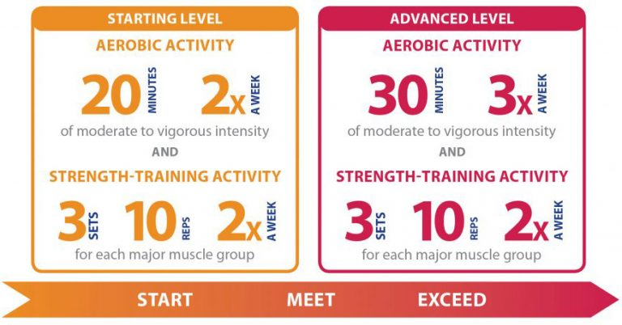****

**Identify the activities they enjoy doing/are interested in (Page 37 or SCI BC resources/InfoLine)**

* Activities they have done in the past, new activities that they were curious to try: At home, recreation, sport
* Exercising with a group or as an individual, inside or outside, communication preferences

**Understand what resources they have available (page 28, 46)**

* For example: Equipment, gym, recreation centres, funding, etc.

**Identify barriers**

* What are some of the things that have gotten in the way of your exercise in the past OR
* Given that this is our goal, is there anything you could see getting in the way?

**Develop solutions (Solutions will be based on a case by case basis- many pages in the toolkit may be relevant for this: see page 2 for table of contents. Sample links in barriers to strategies are provided in table below)**

* Create an action plan (page 15)
* Link solutions to benefits (circle back to ‘WHY’ they want to be active

|  |  |  |  |  |  |  |  |
| --- | --- | --- | --- | --- | --- | --- | --- |
|  | Mon | Tue | Wed | Thur | Fri | Sat | Sun |
| Activity |  |  |  |  |  |  |  |
| Where |  |  |  |  |  |  |  |
| When |  |  |  |  |  |  |  |
| How Long |  |  |  |  |  |  |  |
| Intensity |  |  |  |  |  |  |  |

**Discuss next session**

* What we’ll check up on next session
* Confirm action items (e.g., follow-up with sport organizations, check accessibility of pools, call SCI BC, etc.)
* Questions

Book next session: Example timeline: once/week for 6 weeks (weeks 2-7), survey at 2 months, session 7 at month 3, session 8 at month 4, session 9 at 1-2 weeks before 6 month survey, session 10 at 1-2 weeks before 12 month survey

**Note other services talked about**

* Examples: housing, bowel/bladder, etc.

**Follow-Up Session**

**Client:**

**Date:**

**Session duration:**

**Contacted by: Videoconference, Telephone, or in-person?**

* **Check in, give a summary of what was talked about last session**
* **Check what they did for activity**
* **Follow-up on action items**
* **Ask about barriers/facilitators**
* **Develop solutions/give praise**

**Note other services talked about**

* Examples: housing, bowel/bladder, etc.

|  |  |
| --- | --- |
| Barrier | Strategy from ProacTive SCI Toolkit |
| Lack of energy | Benefits  Activity idea ramp  SMART goals  Graded tasks |
| Emotional distress | Peer to peer connections  Other professional, supports, and organizations |
| Pain | Benefits  Activity idea ramp  SMART goals  Graded tasks |
| Fatigue | Benefits  Activity idea ramp  SMART goals  Graded tasks |
|  |  |
| Moving around within the home | Peer to peer connections  Physical activity prescription: home  Active Homes |
| Problems with self-care | Peer to peer connections  Educational videos |
| Difficulty for women to do PA with men | Benefits  Activity idea ramp  Basic physical activity prescription: home  Adapting common exercise equipment |
| Lack of time due to work | Problem solving  Action planning  SMART goals setting  Activity idea ramp  HIIT |
| Problems with work activities | Problem solving |
|  |  |
| Price of equipment | Finance and transportation  Link to facilities and resources |
| Lack of equipment | Finance and transportation  Link to facilities and resources |
| Inaccessibility of adapted equipment | Adapting common exercise equipment  Link to facilities and resources  Activity idea ramp |
| Inability to obtain and handle required equipment | Finance and transportation  Link to facilities and resources  Activity idea ramp  Graded tasks  Other professional, supports, and organizations (family) |
| Low accessibility of facilities | Link to facilities and resources  Activity idea ramp  Basic physical activity prescription: home  Adapting common exercise equipment |
| Low accessibility of buildings | Link to facilities and resources  Activity idea ramp  Basic physical activity prescription: home  Adapting common exercise equipment |
| Lack of money | Finance and transportation  Activity idea ramp |
| Costs | Finance and transportation  Activity idea ramp  Link to facilities and resources  Peer to peer connections |
| Family commitments | Other professionals, supports, and organizations |
| Negative attitudes from others | Peer to peer connections  Link to facilities and resources: disability-specific programming |
| Low access to information about availability of resources | Link to facilities and resources  Peer to peer connections |
| Lack of/ difficulties with transportation | Finance and transportation  Basic physical activity prescription: home program |
| Lack of participation opportunities | Link to facilities and resources  Peer to peer connections |
|  |  |
| Age |  |
| Gender |  |
| Dislike | Basic physical activity prescription  Activity idea ramp |
| Embarrassment, feelings of incompleteness, dissatisfaction with the body | Benefits of physical activity  Graded tasks  Basic physical activity prescription: home program |
| Fear of injury, poorer condition | Safety  Graded tasks |
| Lack of knowledge | Basic definitions  SCI physical activity guidelines  Basic physical activity prescription  Activity idea ramp |
| Lack of motivation | Benefits of physical activity  Activity idea ramp |
| Lack of time | Problem solving  Action planning  SMART goals setting  Activity idea ramp  HIIT |