Client name:__________________ Physiotherapist name:______________________

**ProACTIVE SCI Physical Activity Form**

**Are you interested in being more physically active?**

**No**:

What might be getting in the way of you wanting to exercise (barriers)? (see benefits/address barriers)

**Yes**:

What are your goals?

(What are you currently doing and how much physical activity would you like to be

doing? What benefits are you hoping to gain?)

**Benefits:**

Examples include improved independence, sleep quality, ability to play with children, more energy, social interaction opportunities, lower risk of depression, and less pain.

**The SCI Physical Activity Guidelines**

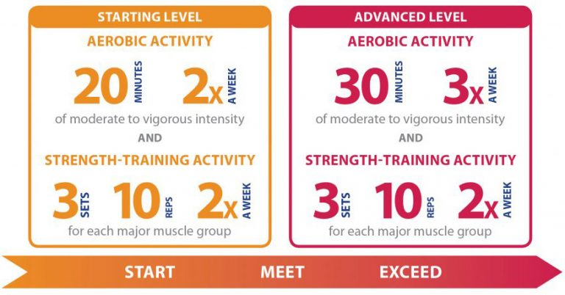



What types of activity do you enjoy/are you interested in doing?

*At home Recreation Competitive Sport*

What resources do you have available to you (e.g., equipment, gym, recreation centers near you,

funding, etc.)

Things that could get in the way (barriers) of your goals?

Your Plan:

|  |  |  |  |  |  |  |  |
| --- | --- | --- | --- | --- | --- | --- | --- |
|  | Mon | Tue | Wed | Thur | Fri | Sat | Sun |
| Activity |  |  |  |  |  |  |  |
| Where |  |  |  |  |  |  |  |
| When |  |  |  |  |  |  |  |
| How Long |  |  |  |  |  |  |  |
| Intensity |  |  |  |  |  |  |  |

Additional notes:

Want to continue the conversation? Contact Spinal Cord Injury BC:

**SCI BC** (https://sci-bc.ca/) 1 800 689 2477 Monday - Friday 9am - 5pm